AGENDA

November Safety Meeting
November 8, 2018

 | Welcome  Michael Terry, Safety and Training Coordinator | 5 min
 | Rodeo Results  Michael Terry, Safety and Training Coordinator  - Winners  - Awards | 30 min
 | Veterans Presentation  Elizabeth Hawks, H.R. Generalist | 5 min
 | Safety Corner  Alan Simpson, Operations Trainer | 10 min
 | Questions/Comments? | 10 min

Please print & sign the agenda.

Name: (please print):______________________________ (please sign) _________________________________

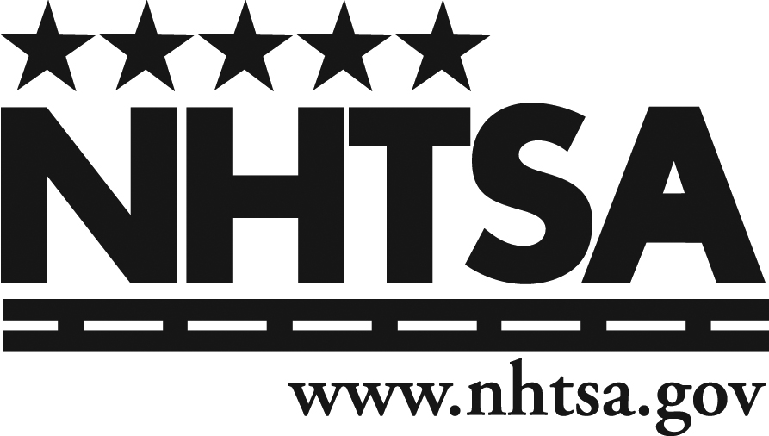
Date: __________________

